**QUIZZES**

**PL/SQL PROGRAMMING**

1. Which of the following is not a PL/SQL unit?

Answer: Table.

1. What will be the output of the following code snippet?

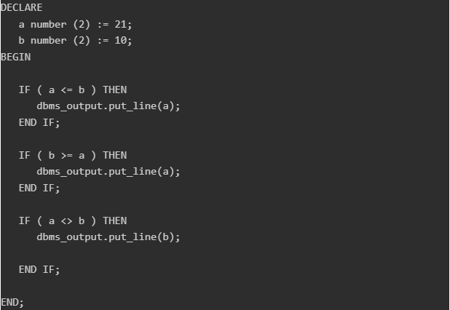

Answer: 10.

1. Which of the following is not true about labelling PL/SQL loops?

Answer: The label should be enclosed by double angle brackets (<< and >>).

1. Consider the following code snippet: how many times the loop will run?

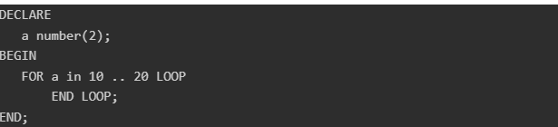

Answer: 11.

1. Which of the following is not true about PL/SQL cursors?

Answer: A cursor is a view on the table.

1. The following code tries to fetch some information from all the rows in a table named customers for use in a PL/SQL block. What is wrong in the following code?

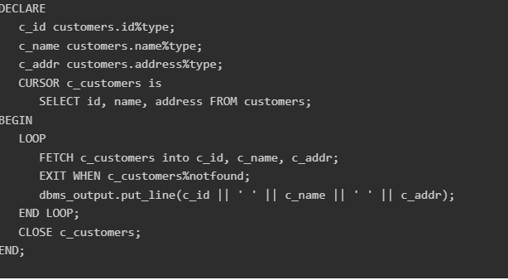

Answer: The cursor is not opened.

1. Which of the following is not true about PL/SQL triggers?

Answer: None of the above.

1. All objects placed in a package specification are called

Answer: Public objects.

1. Which of the following code is the correct syntax for creating an index-by table named salary that will store integer values along with names and the name field will be the key?

Answer: TYPE salary IS TABLE OF NUMBER INDEX BY VARCHAR(20);

1. What will be the output of the following code?

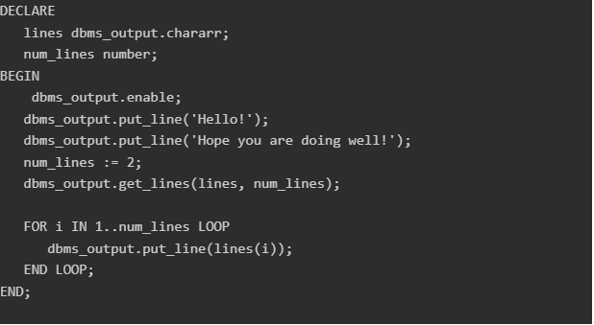

Answer: Hello!

Hope you are doing well!